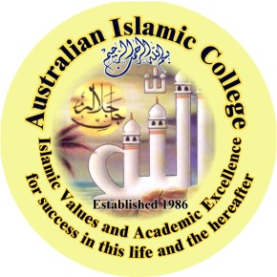
Australian Islamic College (Perth) Inc
PO BOX 252 Cloverdale Western Australia 6985

Tel: (618) 9362-5340 Fax: (618) 9355-2988
Website: www.aic.wa.edu.au Email: info@aic.wa.edu.au

Dianella College: 81 Cleveland St. Dianella Tel: (618) 9375 9770 Thornlie College: 17 Tonbridge Way, Thornlie Tel: (618) 9493 2718 Kewdale College: 139 President Street, Kewdale Tel: (618) 9362 2100

29th October 2012

Dear Parents of Year 9 & Year 10,

Assalamu’Alaikum

I am pleased to advise that the Islamic Schools Association of Australia (ISAA) is in the process of finalizing an Umrah trip in 2013 for students in Year 10 and Year 11 next year.

ISAA has been working closely with the Ministry of Education in Saudi Arabia to arrange such a visit for students of Islamic Schools in Australia. The Umrah visit will be a fully organised tour and will include an educational program including visits to other religious, educational and cultural places. The program may also include a side trip to Egypt’s historical places.

All students from ISAA schools across Australia in Year 10 and Year 11 will be given this opportunity.

We are currently seeking expressions of interests for the visit in 2013.

Some of the general details are as follows:
When: April 2013. Approximately two weeks (possibly one week of school holidays).

Cost: It is anticipated the cost will be approximately $3,000 for each student, including airfares to be paid by parents.

Who: The visit will be restricted to students in year 10 and 11 in 2013. No younger students will be permitted under any circumstances.
Supervision: Sufficient female and male supervisors for girls and boys will be organised. As all students will be travelling as a single group, supervising staff will assume generalised responsibility as well as responsibility for their own students.
Program: The program within Saudi Arabia will be fully organised and managed through the Ministry of Education to make the experience an educational and cultural one. Umrah is part of the package.
Arrangements: All arrangements for Visas will be managed by ISAA.

If you are interested for your son or daughter please complete the attached form and return to the Front Administration Office by Friday 9th November. We will then keep you updated with further details as they come to hand and anticipate confirmation of the trip by end of Term 4, 2012 with a deposit paid.

This is an exciting opportunity for our students to perform the Umrah ritual and experience the sanctity of our holy cities and our Islamic heritage. In addition this experience will allow our students to gain the opportunity to establish friendships across our schools and states and will assist the development of unity within our communities in the future Insha’Allah.
Should you have any question please do not hesitate to contact Sr Amna or Sr Uswa by calling 93622100 during office hours.

Wassalam

Br Abdullah Khan (Chair ISAA Executive Committee)
Executive Principal
Australian Islamic College (Kewdale, Thornlie & Dianella)

